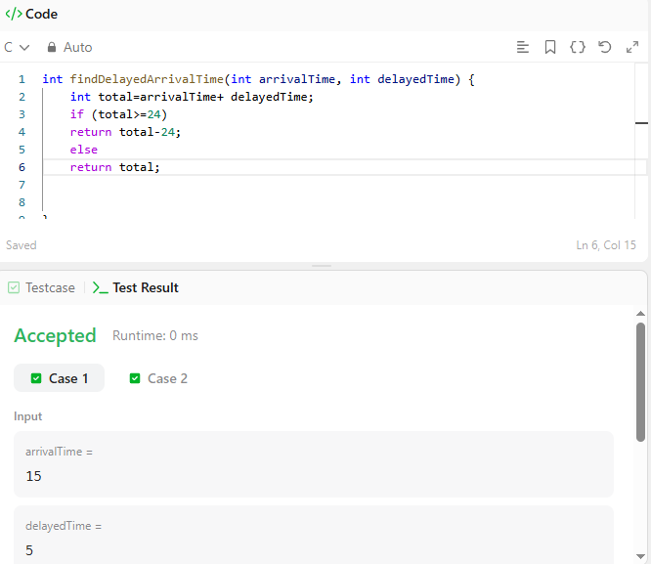

CODE-

int findDelayedArrivalTime(int arrivalTime, int delayedTime) {
int total=arrivalTime+ delayedTime;
if (total>=24)
return total-24;
else
return total;
}

LINK-

https://leetcode.com/problems/calculate-delayed-arrival-time/

